Provenance Challenge

Workflow implementation in NCSA CyberIntergrator

Sang-Chul Lee, Luigi Marini, Joe Futrelle and Peter Bajcsy
Sep 8, 2006

Description of the provenance challenge workflow implementation:

According to the original sequence of the workflow steps defined at the Provenance Challenge URL (http://twiki.ipaw.info/bin/view/Challenge/FirstProvenanceChallenge), we adopted several tools to support stages 1, 2 and 3 by wrapping them inside of the CyberIntegrator. The original implementation of the stages 4 and 5 using the FSL software (http://www.fmrib.ox.ac.uk/fsl/) could not be executed on the Windows platform. Thus, the stage 4 functionality was implemented in NCSA Image To Learn (Im2Learn) and the stage 5 functionality was accomplished by using ImageMagik software package (http://www.imagemagick.org).

The definition of stages was not explicitly embedded into the CyberIntegrator execution. Each stage of the provenance challenge was executed by linking multiple software components that accomplished the functionality defined by a stage.

Description of provenance gathering:
CyberIntegrator collects a hierarchy of provenance information about each execution. Each CyberIntegrator execution is described by its specific executor (e.g., Im2Learn), execution timestamps, a creator, and a step. Steps are characterized by a tool name, inputs, outputs and parameter descriptors. Parameter descriptors consist of a parameter name and multiple properties described by property names and values, see Figure 1. The hierarchy of provenance information was designed based on a thorough study of the provenance gathering challenges by the team members.

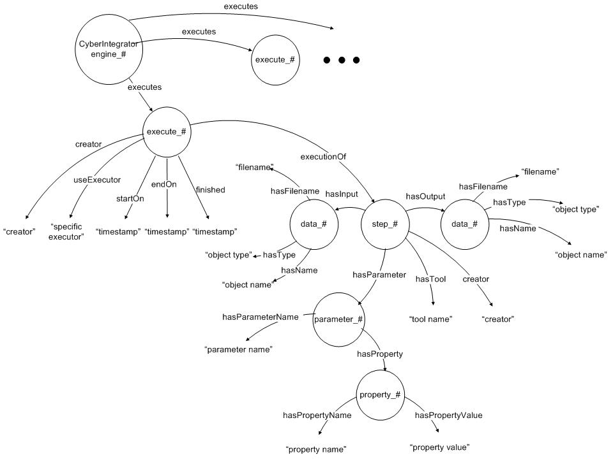
Figure 1: A schematic graph of RDF triple generation inside of CyberIntegrator.

Execution of provenance challenge workflow inside of CyberIntegrator:

After inserting the provenance challenge components into CyberIntegrator, the workflow was created according to the provenance challenge stages. The meta-workflow was saved and re-run multiple times to generate provenance information with unique identifiers. Using the unique identifiers (UUID) for every execution, we were able to generate provenance information for answering all queries. Figure 2, Figure 3 and Figure 4 show the execution in progress as illustrated in a data status pane (waiting, running and done) and a graph of the meta-workflow.

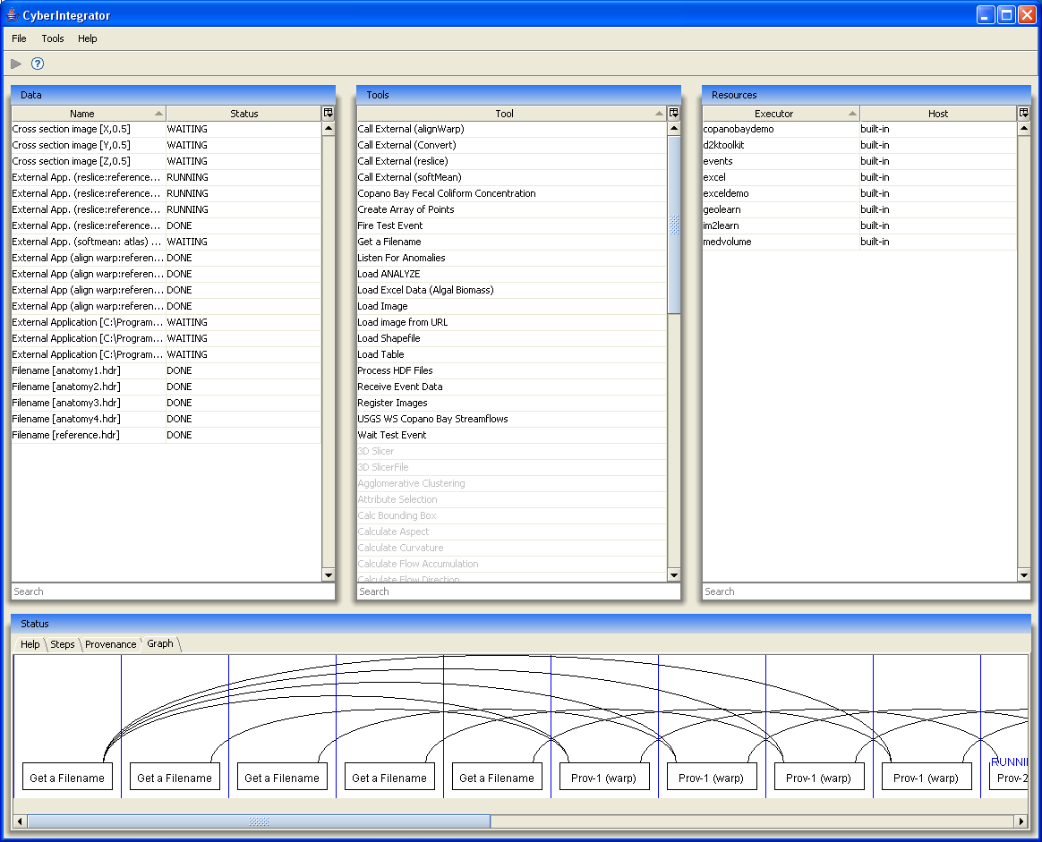
Figure 2: Provenance challenge workflow execution in CyberIntegrator: stage 1 has been completed and stage 2 is running.

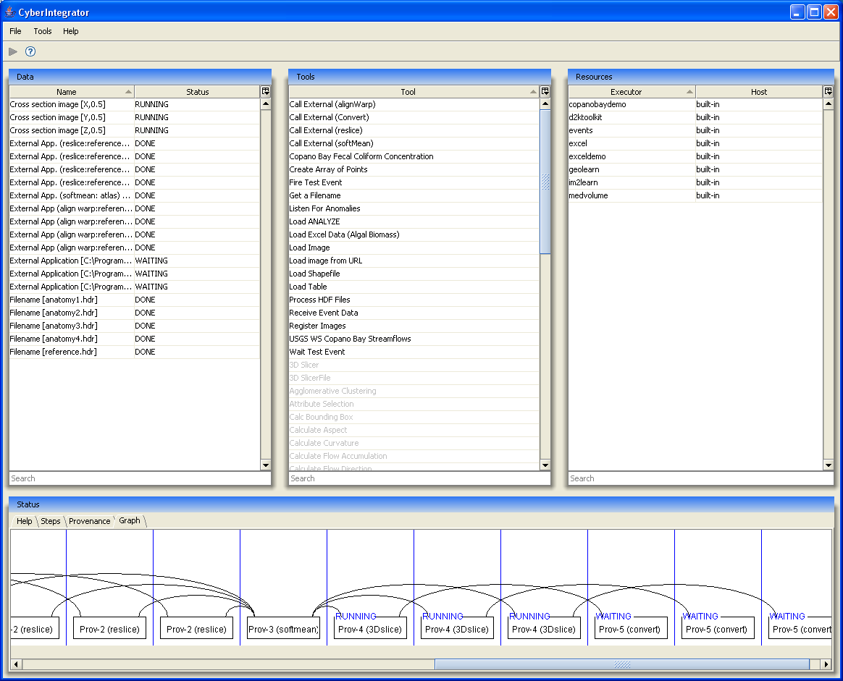
Figure 3: Provenance challenge workflow execution in CyberIntegrator: stage 3 has been completed, and stage 4 is running.

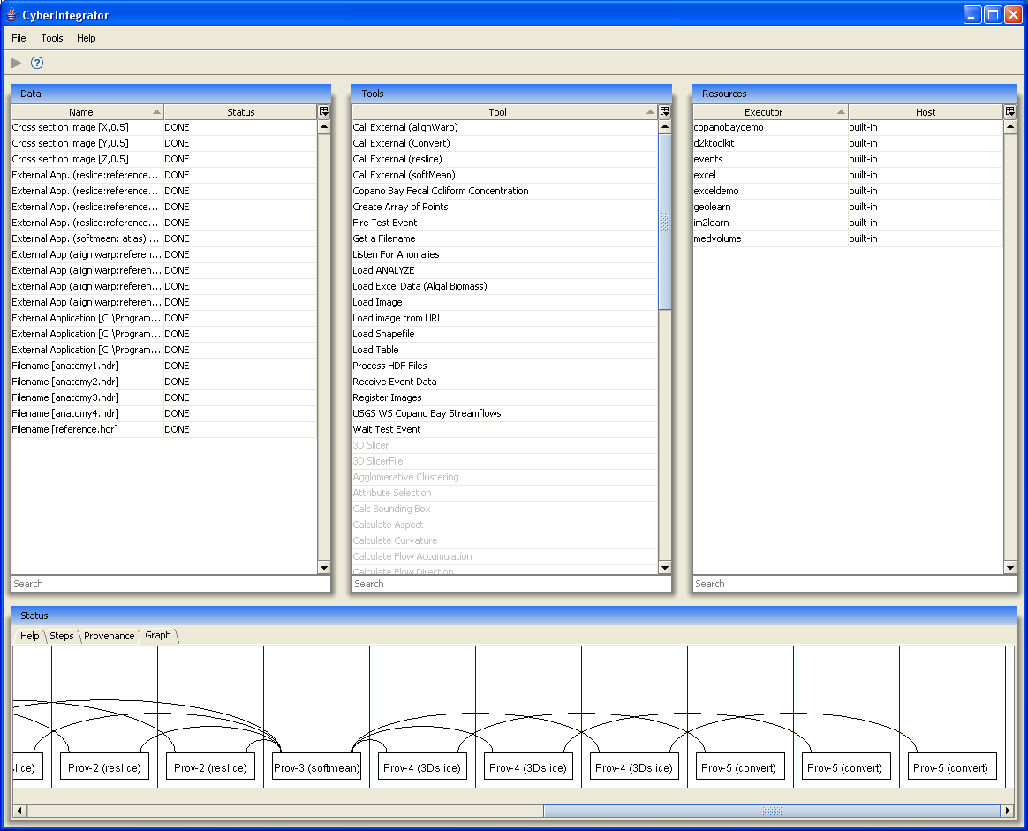
Figure 4: Provenance challenge workflow execution in CyberIntegrator: stage 5 has been completed.

