IPAW Provenance Challenge
Karen Schuchardt, Eric Stephan, Tara Talbott, George Chin
Pacific Northwest National Laboratory

Methodology

We simulated execution of the workflow using the Kepler workflow engine (kepler-project.org). Creating the workflow specification involved coding up stubs for each of the processes, known as Actors in Kepler terminology, in the scenario (e.g. Align Warp through Convert). Each Actor was coded with input and output ports to match the scenario specification and given additional parameters which allow the user to configure how the Actor performs. Figure 1 is a graphical depiction of our simulated workflow. Data files were passed between actors as references to files. Similarly, the original input files were represented as references to files using the Constant String actor.

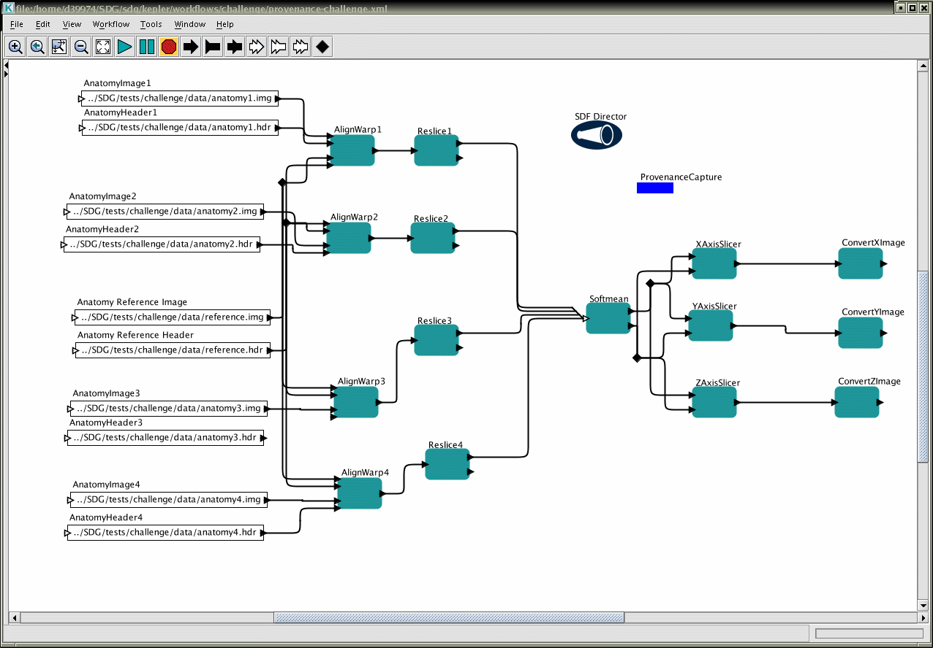

Figure 1: Provenance challenge workflow depicted in Kepler

Methods were added to Kepler to dynamically capture execution activities and artifacts of the workflow. This is represented by the blue rectangle labeled ProvenanceCapture in the figure. The provenance capture mechanism is implemented as a passive listener to events produced by the execution engine. Events include: start, stop, error, actor firing, data token sent, and a special provenance events that allow an individual actor to contribute information known only it. The latter capability was not used for this scenario. Initial examples of how to tap into Kepler events was provided by the Kepler development team. All information associated with the events are captured as RDF triples. Data files used in a workflow are saved to the provenance store.

The external annotations required for queries 8 and 9 were added programmatically for easy repeatability during testing. However they could have been added through a notebook annotation capability or tools.

We created a second workflow in Kepler to generate graphical representations of the query results. This workflow included a new query actor that supports our query language and also leveraged existing Kepler actors such as the web service, xslt transformer, and image viewer actors. A query is executed, the result transformed, rendered into an image, and then viewed. This workflow was used to create the figures in this document.

Technology

For data/metadata management, we used and extended the Scientific Annotation Middleware (SAM) (http://collaboratory.emsl.pnl.gov/docs/collab/sam/2.1/SAMDownload.html) technology.
SAM provides scientific content management (data and metadata) as well as services such as dynamic data translation and metadata extraction. SAM’s primary interface was originally based on the WebDAV (webdav.org) protocol, but has been enhanced to support the provenance interface of the URIQA protocol (http://sw.nokia.com/uriqa/URIQA.html) and is additionally migrating to JSR170 codebase which will provide, among other things, a separation of data from metadata. SAM also incorporates an implementation of the Data Format Description Language (DFDL), called Defuddle. The Global Grid Forum DFDL working group is currently in the process defining an XML-based language standard for describing the structure of binary and character encoded (ASCII/Unicode) data in file(s) and/or stream(s) so that their format, structure, and metadata can be exposed. Defuddle is a prototype DFDL-parser capable of reading DFDL descriptions and mapping the data into the XML schema given by the DFDL description. SAM’s primary query language is based on DASL, with extensions for semantic searching. The query language is described later.

As mentioned, SAM supports dynamic metadata extraction. Extractors are registered against mime-types and invoked when data of that type is uploaded. Extractors can take one of several forms: XLST scripts for xml data, customs web services, or defuddle (defuddle.pnl.gov), a generic parsing engine capable of supporting arbitrary text or binary data. Defuddle was used to extract data for query 4.

Several other technologies contributed to our effort: the graph rendering program graphviz (graphviz.org), hosted as webservice, generated graphs; axis was used to deploy web services; XSLT was used to transform data.into a format suitable for graphviz.

Provenance Model

Any “thing”, for which we want to capture some information (actor, piece of data, parameter etc), is given a unique id and then properties and relationships are associated with that id. Figure 2 below shows the primary “things” we capture provenance on and what that provenance is in the context of this challenge. In an actual system, the “things” we capture provenance would be somewhat larger. We would include the workflow descriptors, actor descriptors, and versions of each of these at a minimum. We currently use generated urls for the unique ids but have an lsid server deployed and plan to experiment using it instead of generated urls.

Links are captured by the provenance store allowing forward and backward traversal. Relationship cardinality is captured as only information and the provenance store does not require or act upon this information. Because SAM supports schema-less metadata, no predefined metadata structures are required and as a result any metadata can be captured at any time. This capability is denoted by the [arbitrary triple]* notation in the figure. Inputs, outputs, and parameters can be captured as one of hasValue, hasHashOfValue, or hasRefToValue. The latter is used to point to raw data artifacts such as image files.

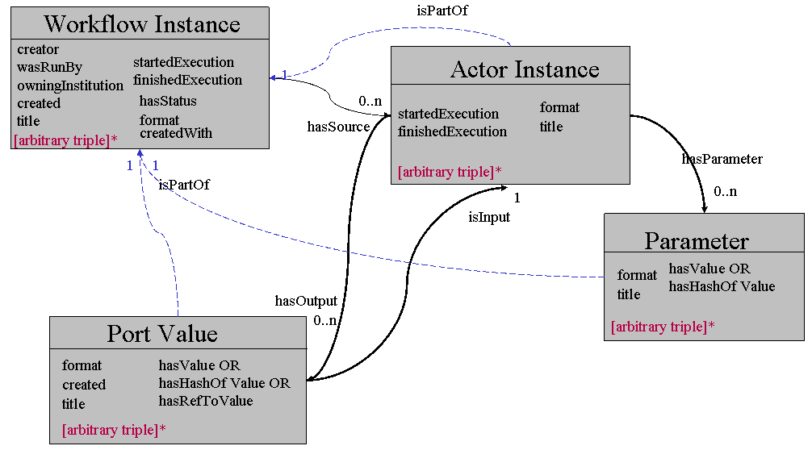
Figure 2. Provenance Data Model

Table 1 provides a description of our provenance schema. We were able to leverage both from existing Dublin Core (dc) standards and conventions established by the SciDAC Collaboratory for MultiScale Chemical Sciences project.

Schema Property | Description
dc:format | Defined by http://dublincore.org/documents/dces/
dc:title | Defined by http://dublincore.org/documents/dces/
dc:creator | Defined at http://dublincore.org/documents/dces/
wasRunBy | String, User provided name of person that executed the workflow
createdWith | String, Name & version of software used
owningInstitution | String, Name of the institution responsible for the data.
startedExecution | Date, When an activity started
finishedExecution | Date, When an activity started
hasStatus | String Status of an executable entity (running, completed, failed)
value | Byte array, Raw data value
hasHashOfValue | String, Has of value
isPartOf | Link, Denotes a relationship between an entity and the thing it belongs to
hasSource | Link, Denotes a relationship to sources in a workflow (i.e. starting points)
isInput | Link, Denotes a relationship between a piece of input data and a receiver of that data
hasOutput | Link, Denotes a relationship between a piece of data and the entity that created it
hasParameter | Link, Denotes a relationship between a process and its configurable parameters

Table 1: Provenance schema used in the challenge

Query Language

To perform the challenge we based the query language on the DAV Search and Locating protocol already supported on SAM. By default DASL supports the “Basicsearch” grammar, to perform the challenge, we created a new grammar by extending the “Basicsearch” grammar, we call the Semantic Extended DASL (SEDASL). The main difference between Basicsearch and SEDASL is that Basicsearch only traverses collections and documents in a top-down (forward) direction, while SEDASL is able to traverse the semantically linked metadata in the workflow bi-directionally. An example DASL query is shown below with extensions highlighted in blue; the full DASL specification is located at http://www.webdav.org/dasl/. It should be noted that while we did create a new grammar, because of time constraints we did all of our grammar prototyping under the guise of the Basicsearch grammar. Extensions made should have been made though a separate namespace, but in interest of simplicity they were left in the DAV: namespace.

<d:searchrequest xmlns:d="DAV:"
xmlns:s=http://jakarta.apache.org/slide/
xmlns:xsi="http://www.w3.org/2001/XMLSchema-instance">
<d:basicsearch>
<d:select>
<d:prop>
<d:getcontentlength/>
</d:prop>
<!-—alternately <d:allprop /> -->

<d:format d:includelinks="false">gxl</d:format>
</d:select>
<d:from>
<d:scope>
<d:href>/files/workflow1/</d:href>
<!—- alternately d:query
<d:query>
<d:href>/sam/files/workflow1/</d:href>
<d:eq>
<d:prop>
<d:displayname/>
</d:prop>
<d:literal>image1</d:literal>
</d:eq>
</d:query>
-->

<d:depth>infinity</d:depth>
<d:min-depth>0</d:min-depth>

<d:following d:direction="reverse">
<d:prop>
<d:isInput />
<d:hasParameter d:direction=”forward” />
</d:prop>
<d:stop-condition >
<d:eq>
<d:prop>
<d:instantiationOf />
</d:prop>
<d:literal>Softmean</d:literal>
</d:eq>
</d:stop-condition>
</d:following>
</d:scope>
</d:from>
<d:where>
<d:or>
<s:propcontains>
<d:prop><d:title/></d:prop>
<d:literal>atlas </d:literal>
</s:propcontains>
<d:eq>
<d:prop>
<d:date />
</d:prop>
<d:typed-literal xsi:type="xs:dateTime">
2006-01-01
</d:typed-literal>
</d:eq>
</d:or>
</d:where>
</d:basicsearch>
</d:searchrequest>

Figure 3. SEDASL Query Language Example

The Basic DASL grammar consists of three main sections:
- Select, which defines the result record, consists of a set of properties and values.
- From, which defines the query scope, is composed of one or more scope elements and defines the region to search in along with the search depth.
- Where, defines the search condition for inclusion of resources in the result set.

The SEDASL grammar features the following extensions:
- The ‘select’ element was given options to format the search result in several different formats; GXL (an xml-based graph language), RDF, or the standard DAV response. You can also configure the output to display nodes generated from links within the data, which would not otherwise be in the result set.
- The ‘from’ grammar was extended with the ability to specify conditional information for the scope of the query. In the basicsearch grammar you are limited only specifying an initial URL to start the search. SEDASL provides you the ability specify search criteria to discover an initial scope, rather than a URL. It also contains capabilities to compose the search pool based on semantic links between objects, rather than a collection based structure. These links are created at the time of search by defining which properties should be used to create semantic links. As a part of the semantic search pool, there is also the capability to specify the direction that the links are to be followed, a precise search depth (i.e. minimum and maximum depth), and instructions to stop following links when certain conditions are met.
- The ‘where’ element was modified with the addition of a prop-contains condition, similar to a like statement or regular expression. This addition was made in Jakarta Slide, the open-source software that SAM is built on.

Results: Core Provenance Queries

This section depicts the methods and technologies we used to yield results for the provenance challenge.

1) Find the process that led to Atlas X Graphic / everything that caused Atlas X Graphic to be as it is. This should tell us the new brain images from which the averaged atlas was generated, the warping performed etc.

Discussion:
The SEDASL scope query was used to first find the Atlas X Graphic file and then reverse semantic links were used to determine all processes (Kepler actors) and files that were responsible for generating this file. The scope was set to infinite to represent all provenance responsible for the generation of the file. The result format was set to GXL and converted to a gif image through a separate process.

<d:search xmlns:d="DAV:">
<d:basicsearch>
<d:select>
<d:prop>
<d:allindexedprop />
</d:prop>
<d:format d:include-links="false">gxl</d:format>
</d:select>
<d:from>
<d:scope>
<d:following d:direction="reverse">
<d:prop>
<d:hasOutput />
<d:isInput />
<d:instantiationOf />
<d:hasParameter d:direction="forward" />
</d:prop>
</d:following>
<d:query>
<d:href>/sam/users/sdg/karen/workflow2125321801/</d:href>
<d:eq xmlns:s="http://jakarta.apache.org/slide/">
<d:prop>
<d:title />
</d:prop>
<d:literal>atlas-x.gif</d:literal>
</d:eq>
</d:query>
<d:depth>INFINITE</d:depth>
<d:min-depth>0</d:min-depth>
</d:scope>
</d:from>
</d:basicsearch>
</d:search>

Figure 4 SEDASL query for provenance query 1

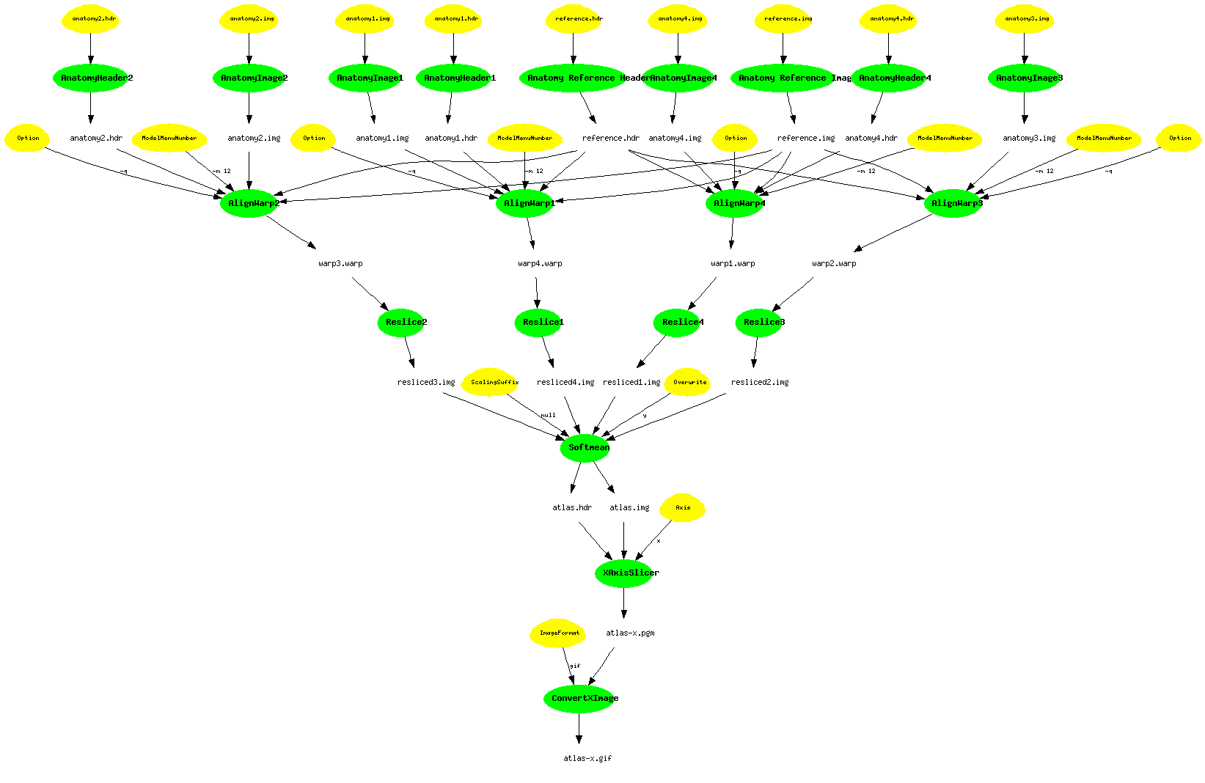
Figure 5 Query 1 Results

2) Find the process that led to Atlas X Graphic, excluding everything prior to the averaging of images with softmean.

Discussion:
Search criteria was used to first find the Atlas X Graphic, and follow semantic links, similar to Query 1, until the process Softmean was found. Because the scope was set to stop when the Softmean process was found, only the links between the graphic and the Softmean process were returned. The result format was set to GXL and converted to a gif image.

<d:searchrequest xmlns:d="DAV:">
<d:basicsearch>
<d:select>
<d:prop>
<d:format />
<d:title />
<d:isInput />
<d:hasOutput />
<d:hasValue />
<d:hasHashOfValue />
<d:hasRefToValue />
<d:instantiationOf />
<d:hasParameter />
</d:prop>
<d:format d:include-links="false">gxl</d:format>
</d:select>
<d:from>
<d:scope>
<d:following d:direction="reverse">
<d:prop>
<d:isInput />
<d:hasOutput />
<d:hasRefToValue />
<d:instantiationOf />
<d:hasParameter d:direction="forward" />
</d:prop>
<d:stop-condition>
<d:eq>
<d:prop>
<d:title />
</d:prop>
<d:literal>Softmean</d:literal>
</d:eq>
</d:stop-condition>
</d:following>
<d:query>
<d:href>/sam/users/sdg/karen/workflow2125321801/</d:href>
<d:eq>
<d:prop>
<d:title />
</d:prop>
<d:literal>atlas-x.gif</d:literal>
</d:eq>
</d:query>
<d:depth>INFINITE</d:depth>
<d:min-depth>0</d:min-depth>
</d:scope>
</d:from>
</d:basicsearch>
</d:searchrequest>

Figure 6 SEDASL query for provenance query 2

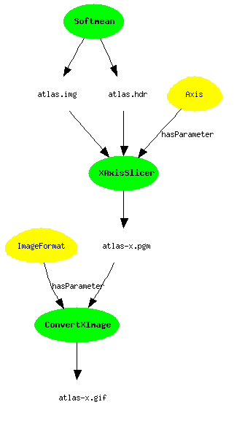
Figure 7 Query 2 results

3) Find the Stage 3, 4 and 5 details of the process that led to Atlas X Graphic.

Discussion:
Search criteria was used to first find the Atlas X Graphic, and follow semantic links, similar to Queries 1 and 2, except that the minimum and maximum scope depths were used to return certain stages of the workflow. The result format was set to GXL and converted to a gif image.

<d:searchrequest xmlns:d="DAV:">
<d:basicsearch>
<d:select>
<d:prop>
<d:format />
<d:title />
<d:isInput />
<d:hasOutput />
<d:hasValue />
<d:hasHashOfValue />
<d:hasRefToValue />
<d:instantiationOf />
<d:hasParameter />
</d:prop>
<d:format d:include-links="false">gxl</d:format>
</d:select>
<d:from>
<d:scope>
<d:following d:direction="reverse">
<d:prop>
<d:isInput />
<d:hasOutput />
<d:hasRefToValue />
<d:instantiationOf />
<d:hasParameter d:direction="forward" />
</d:prop>
</d:following>
<d:query>
<d:href>/sam/users/sdg/karen/workflow2125321801/</d:href>
<d:eq>
<d:prop>
<d:title />
</d:prop>
<d:literal>atlas-x.gif</d:literal>
</d:eq>
</d:query>
<d:depth>5</d:depth>
<d:min-depth>0</d:min-depth>
</d:scope>
</d:from>
</d:basicsearch>
</d:searchrequest>

Figure 8 SEDASL query for provenance query 3

Figure 9 Query 3 results

4) Find all invocations of procedure align_warp using a twelfth order nonlinear 1365 parameter model (see model menu describing possible values of parameter "-m 12" of align_warp) that ran on a Monday.

Discussion:
Search criteria in the scope was used to find “ModelMenuNumber” parameters with the value “-m 12” and semantic links were used to find the associated process. Search criteria in the where clause was then used to filter the AlignWarp results created on a given day of the week (in our case Thursday). The result format was set to GXL and converted to a gif image.

<d:searchrequest xmlns:d="DAV:">
<d:basicsearch>
<d:select>
<d:prop>
<d:displayName />
<d:format />
<d:title />
<d:isPartOf />
</d:prop>
<d:format d:include-links="true">gxl</d:format>
</d:select>
<d:from>
<d:scope>
<d:following>
<d:prop>
<d:hasParameter d:direction="reverse" />
</d:prop>
</d:following>
<d:query>
<d:href>/sam/users/sdg/karen/</d:href>
<d:and>
<d:eq>
<d:prop>
<d:title />
</d:prop>
<d:literal>ModelMenuNumber</d:literal>
</d:eq>
<d:eq>
<d:prop>
<d:value />
</d:prop>
<d:literal>-m 12</d:literal>
</d:eq>
</d:and>
</d:query>
<d:depth>INFINITE</d:depth>
<d:min-depth>0</d:min-depth>
</d:scope>
</d:from>
<d:where>
<d:and>
<s:propcontains xmlns:s="http://jakarta.apache.org/slide/">

<d:prop>
<d:startedExecution />
</d:prop>
<d:literal>Th</d:literal>
</s:propcontains>
<s:propcontains xmlns:s="http://jakarta.apache.org/slide/">

<d:prop>
<d:instantiationOf />
</d:prop>
<d:literal>AlignWarp</d:literal>
</s:propcontains>
</d:and>
</d:where>
</d:basicsearch>
</d:searchrequest>

Figure 10 SEDASL query for provenance query 4

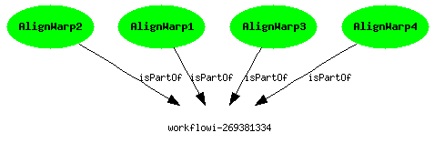
Figure 11 Query 4 results

5) Find all Atlas Graphic images outputted from workflows where at least one of the input Anatomy Headers had an entry global maximum=4095. The contents of a header file can be extracted as text using the scanheader AIR utility

Discussion:
Our development team found the scanheader source code which yielded the binary structure of the image header. Based on this structure, a DFDL schema along with a corresponding XSLT file was created and registered on the SAM server. When the workflow runs, metadata from the image header is automatically extracted and associated with the file. Search criteria was used to first find all anatomy header files with a ‘global maximum’ property of ‘4095’ and follow semantic links to generate a search pool of all items below the header in the workflow. Search criteria in the where clause was then used to return the atlas image.

<?xml version='1.0' encoding='UTF-8'?>
<dfdl:DFDL xmlns:dfdl="DFDL">
<dfdl:sizeofhdr>348</dfdl:sizeofhdr>
<dfdl:extents>16384</dfdl:extents>
<dfdl:regular>r</dfdl:regular>
<dfdl:dims>4</dfdl:dims>
<dfdl:xdim>256</dfdl:xdim>
<dfdl:ydim>256</dfdl:ydim>
<dfdl:zdim>128</dfdl:zdim>
<dfdl:tdim>1</dfdl:tdim>
<dfdl:datatype>4</dfdl:datatype>
<dfdl:bits>16</dfdl:bits>
<dfdl:xsize>1.0</dfdl:xsize>
<dfdl:ysize>1.0</dfdl:ysize>
<dfdl:zsize>1.25</dfdl:zsize>
<dfdl:glmax>4095</dfdl:glmax>
<dfdl:glmin>0</dfdl:glmin>
</dfdl:DFDL>

Figure 12: Raw Defuddle translation of the header

<d:searchrequest xmlns:d="DAV:">
<d:basicsearch>
<d:select>
<d:prop>
<d:displayName />
<d:format />
<d:title />
<d:hasParameter />
</d:prop>
<d:format d:include-links="false">gxl</d:format>
</d:select>
<d:from>
<d:scope>
<d:following>
<d:prop>
<d:isInput />
<d:hasOutput />
<d:hasRefToValue />
<d:instantiationOf />
<d:hasParameter />
</d:prop>
</d:following>
<d:query>
<d:href>/sam/users/sdg/karen/</d:href>
<d:and>
<s:propcontains xmlns:s="http://jakarta.apache.org/slide/">
<d:prop>
<d:title />
</d:prop>
<d:literal>anatomy*.hdr</d:literal>
</s:propcontains>
<d:eq xmlns:s="http://jakarta.apache.org/slide/">
<d:prop>
<d:glmax />
</d:prop>
<d:literal>4095</d:literal>
</d:eq>
</d:and>
</d:query>
<d:depth>INFINITE</d:depth>
<d:min-depth>0</d:min-depth>
</d:scope>
</d:from>
<d:where>
<d:eq>
<d:prop>
<d:title />
</d:prop>
<d:literal>atlas.img</d:literal>
</d:eq>
</d:where>
</d:basicsearch>
</d:searchrequest>

Figure 13: SEDASL query for provenance query 5

<D:multistatus xmlns:D="DAV:">
<gxl xmlns="" xmlns:cmcs="http://purl.oclc.org/NET/cmcs/internal/schema/" xmlns:dc="http://purl.org/dc/elements/1.1/" xmlns:sam="http://purl.oclc.org/NET/SAM/mms">
<graph>
<node id="node0">
<attr name="Label">
<string></string>
<dav:href xmlns:dav="DAV:">
/users/sdg/karen/question7/workflow488799345/1378310357atlas.img
</dav:href>
</attr>
<attr name="title" xmlns="DAV:">
<string>atlas.img</string>
</attr>
</node>
</graph>
</gxl>
</D:multistatus>

Figure 14: Query 5 raw results

6) Find all output averaged images of softmean (average) procedures, where the warped images taken as input were align_warped using a twelfth order nonlinear 1365 parameter model, i.e. "where softmean was preceded in the workflow, directly or indirectly, by an align_warp procedure with argument -m 12."

Discussion:
Search criteria was used to find output from SoftMean process which was preceded by processes containing the parameter “ModelMenuNumber” and value “-m 12” within a workflow. The result format was set to GXL and converted to a gif image.

<d:searchrequest xmlns:d="DAV:">
<d:basicsearch>
<d:select>
<d:prop>
<d:format />
<d:title />
<d:isInput />
<d:hasOutput />
<d:hasValue />
<d:hasHashOfValue />
<d:hasRefToValue />
<d:instantiationOf />
</d:prop>
<d:format d:include-links="false">gxl</d:format>
</d:select>
<d:from>
<d:scope>
<d:following>
<d:prop>
<d:isInput />
<d:hasOutput />
<d:hasRefToValue />
<d:instantiationOf />
<d:hasParameter d:direction="reverse" />
</d:prop>
</d:following>
<d:query>
<d:href>/sam/users/sdg/karen/</d:href>
<d:and>
<d:eq>
<d:prop>
<d:title />
</d:prop>
<d:literal>ModelMenuNumber</d:literal>
</d:eq>
<d:eq>
<d:prop>
<d:hasValue />
</d:prop>
<d:literal>"-m 12"</d:literal>
</d:eq>
</d:and>
</d:query>
<d:depth>INFINITE</d:depth>
<d:min-depth>0</d:min-depth>
</d:scope>
</d:from>
<d:where>
<d:eq>
<d:prop>
<d:title />
</d:prop>
<d:literal>Softmean</d:literal>
</d:eq>
</d:where>
</d:basicsearch>
</d:searchrequest>

Figure 15: SEDASL query for provenance query 6

<D:multistatus xmlns:D="DAV:">
<gxl xmlns="" xmlns:cmcs="http://purl.oclc.org/NET/cmcs/internal/schema/"
xmlns:dc="http://purl.org/dc/elements/1.1/"
xmlns:sam="http://purl.oclc.org/NET/SAM/mms">
<graph>
<node id="node0">
<attr name="Label">
<string></string>
<dav:href xmlns:dav="DAV:">
/users/sdg/karen/workflow-1590847631/-885893539atlas.img
</dav:href>
</attr>
<attr name="title" xmlns="DAV:">
<string>atlas.img</string>
</attr>
</node>
</graph>
</gxl>
</D:multistatus>

Figure 16: Query 6 raw results

7) A user has run the workflow twice, in the second instance replacing each procedures (convert) in the final stage with two procedures: pgmtoppm, then pnmtojpeg. Find the differences between the two workflow runs. The exact level of detail in the difference that is detected by a system is up to each participant.

We developed a workflow graph comparison tool called “workcomp” that performs a node-by-node and edge-by-edge comparison of two workflow graphs. Two nodes in two individual graphs are considered exactly matching if their metadata are equivalent for the attributes of title, instantiationOf, source, value, and format. The code may be configured to include other node attributes in the comparison. The code also compares the edges coming into and leaving the nodes to verify the in- and out-degrees and edge labels. The code will also find similar nodes where attributes and edges match to some defined threshold. Thus, for two nodes in individual graphs to be considered 85% matching, 85% of the node attributes and edges must match. Once matching and similar nodes are found, edges are compared. For edges to match, their connecting nodes must have been found to be matching or similar and edge attributes must match as well. For our test case, the only attribute compared is the label. Like the node attributes, the program may be configured to include other edge attributes.

For question 7, the command, “workcomp –d q7_original_result.xml q7_revised_result.xml” generated the following result.

Total Nodes: 82, 85
Fully Matching Nodes:
node74 - node65 (modelmenunumber-413417418, modelmenunumber, ) - (modelmenunumber175485584, modelmenunumber, )
node77 - node6 (yaxisslicer2053728869, yaxisslicer, yaxisslicer) - (yaxisslicer-2054288679, yaxisslicer, yaxisslicer)
node31 - node36 (anatomyimage1-2080089252, anatomyimage1, anatomyimage1) - (anatomyimage11465177548, anatomyimage1, anatomyimage1)
node13 - node62 (reslice31305153001, reslice3, reslice3) - (reslice3512835460, reslice3, reslice3)
node47 - node32 (-1289354194anatomy2.img, anatomy2.img, ) - (1977715459anatomy2.img, anatomy2.img, )
node23 - node93 (-2141688226resliced3.hdr, resliced3.hdr, ) - (-1077285688resliced3.hdr, resliced3.hdr, )
node65 - node81 (-181889129atlas-z.pgm, atlas-z.pgm, ) - (-1426249450atlas-z.pgm, atlas-z.pgm, )
node43 - node87 (-1652900658anatomy2.hdr, anatomy2.hdr, ) - (-1938843384anatomy2.hdr, anatomy2.hdr, )
node29 - node65 (modelmenunumber-1876298269, modelmenunumber, ) - (modelmenunumber175485584, modelmenunumber, )
node67 - node89 (anatomy reference header1948739095, anatomy reference header, anatomy reference header) - (anatomy reference header-239218874, anatomy reference header, anatomy reference header)
node48 - node52 (881032779atlas-x.pgm, atlas-x.pgm, ) - (-1850349651atlas-x.pgm, atlas-x.pgm, )
node45 - node40 (anatomyimage4855378227, anatomyimage4, anatomyimage4) - (anatomyimage4-1906667665, anatomyimage4, anatomyimage4)
node60 - node65 (modelmenunumber-829183798, modelmenunumber, ) - (modelmenunumber175485584, modelmenunumber, )
node76 - node39 (1739314037anatomy4.img, anatomy4.img, ) - (186833493anatomy4.img, anatomy4.img, )
node9 - node13 (reslice1-123910439, reslice1, reslice1) - (reslice1136255554, reslice1, reslice1)
node20 - node70 (-790501805warp2.warp, warp2.warp, ) - (-8011637warp2.warp, warp2.warp, )
node11 - node10 (axis1260708734, axis, ) - (axis977061030, axis, )
node72 - node77 (anatomyheader3-190399266, anatomyheader3, anatomyheader3) - (anatomyheader3-424778043, anatomyheader3, anatomyheader3)
node40 - node23 (alignwarp2264611356, alignwarp2, alignwarp2) - (alignwarp21192157963, alignwarp2, alignwarp2)
node22 - node26 (946822237reference.hdr, reference.hdr, ) - (-1768071903reference.hdr, reference.hdr, )
node73 - node47 (625380134anatomy1.hdr, anatomy1.hdr, ) - (-1815690263anatomy1.hdr, anatomy1.hdr, )
node49 - node1 (alignwarp4-1268003332, alignwarp4, alignwarp4) - (alignwarp41223957195, alignwarp4, alignwarp4)
node55 - node72 (1794015521anatomy4.hdr, anatomy4.hdr, ) - (1563604160anatomy4.hdr, anatomy4.hdr, )
node56 - node49 (2145197619reference.img, reference.img, ) - (-773892483reference.img, reference.img, )
node80 - node19 (-1813719966resliced1.hdr, resliced1.hdr, ) - (574546454resliced1.hdr, resliced1.hdr, )
node42 - node91 (-1421167334anatomy3.hdr, anatomy3.hdr, ) - (-63213482anatomy3.hdr, anatomy3.hdr, )
node75 - node24 (-302115148reference.img, reference.img, ) - (-1751117906reference.img, reference.img, )
node19 - node5 (anatomyheader41554380994, anatomyheader4, anatomyheader4) - (anatomyheader4-1806436974, anatomyheader4, anatomyheader4)
node10 - node75 (541878523anatomy3.hdr, anatomy3.hdr, ) - (2045388669anatomy3.hdr, anatomy3.hdr, )
node61 - node41 (1082791438resliced4.hdr, resliced4.hdr, ) - (750492856resliced4.hdr, resliced4.hdr, )
node5 - node16 (xaxisslicer-288392718, xaxisslicer, xaxisslicer) - (xaxisslicer537929345, xaxisslicer, xaxisslicer)
node38 - node59 (anatomyheader2-547268478, anatomyheader2, anatomyheader2) - (anatomyheader21092751185, anatomyheader2, anatomyheader2)
node17 - node83 (axis-313430929, axis, ) - (axis-635320917, axis, )
node7 - node21 (reslice4-1152183526, reslice4, reslice4) - (reslice4-814144898, reslice4, reslice4)
node62 - node65 (modelmenunumber-892148628, modelmenunumber, ) - (modelmenunumber175485584, modelmenunumber, )
node12 - node68 (reslice22071801652, reslice2, reslice2) - (reslice2308601796, reslice2, reslice2)
node0 - node78 (2092647242anatomy3.img, anatomy3.img, ) - (-1958108039anatomy3.img, anatomy3.img, )
node32 - node33 (anatomyimage21574303697, anatomyimage2, anatomyimage2) - (anatomyimage2918993022, anatomyimage2, anatomyimage2)
node66 - node84 (1477785733resliced3.img, resliced3.img, ) - (1054621063resliced3.img, resliced3.img, )
node35 - node66 (-1296375495anatomy4.img, anatomy4.img, ) - (-252157305anatomy4.img, anatomy4.img, )
node24 - node90 (-133328662anatomy3.img, anatomy3.img, ) - (-1776024256anatomy3.img, anatomy3.img, )
node39 - node14 (option535935487, option, ) - (option-629490770, option, )
node70 - node60 (1658888393resliced2.hdr, resliced2.hdr, ) - (-137490484resliced2.hdr, resliced2.hdr, )
node37 - node9 (-1576913427atlas-y.pgm, atlas-y.pgm, ) - (-1796875977atlas-y.pgm, atlas-y.pgm, )
node64 - node94 (1035937697reference.hdr, reference.hdr, ) - (-1209126371reference.hdr, reference.hdr, )
node25 - node7 (-1623185601atlas.hdr, atlas.hdr, ) - (-1402008444atlas.hdr, atlas.hdr, )
node30 - node85 (scalingsuffix273683940, scalingsuffix, ) - (scalingsuffix583975768, scalingsuffix, )
node16 - node50 (anatomy reference image-1414263078, anatomy reference image, anatomy reference image) - (anatomy reference image887658486, anatomy reference image, anatomy reference image)
node4 - node27 (1985363487anatomy1.img, anatomy1.img, ) - (857480394anatomy1.img, anatomy1.img, )
node58 - node63 (-700477161anatomy2.img, anatomy2.img, ) - (1146044687anatomy2.img, anatomy2.img, )
node68 - node34 (axis1086554890, axis, ) - (axis526664801, axis, )
node21 - node44 (anatomyheader1-814551664, anatomyheader1, anatomyheader1) - (anatomyheader1-1114450408, anatomyheader1, anatomyheader1)
node51 - node8 (-1451929859atlas.img, atlas.img, ) - (1378310357atlas.img, atlas.img, )
node44 - node11 (-1563453167resliced4.img, resliced4.img, ) - (1352548109resliced4.img, resliced4.img, )
node28 - node45 (2023717680warp1.warp, warp1.warp, ) - (-1476787752warp1.warp, warp1.warp, )
node46 - node28 (-976973867warp4.warp, warp4.warp, ) - (353627296warp4.warp, warp4.warp, )
node54 - node14 (option1144713003, option, ) - (option-629490770, option, )
node63 - node15 (alignwarp1850207028, alignwarp1, alignwarp1) - (alignwarp11310668102, alignwarp1, alignwarp1)
node3 - node79 (anatomyimage3-44822114, anatomyimage3, anatomyimage3) - (anatomyimage3-37115557, anatomyimage3, anatomyimage3)
node71 - node14 (option1853805089, option, ) - (option-629490770, option, )
node79 - node35 (-1176204782anatomy1.img, anatomy1.img, ) - (1223876769anatomy1.img, anatomy1.img, )
node81 - node67 (-1724496774warp3.warp, warp3.warp, ) - (1543951163warp3.warp, warp3.warp, )
node8 - node12 (softmean391011653, softmean, softmean) - (softmean-441843452, softmean, softmean)
node27 - node46 (-941018834resliced1.img, resliced1.img, ) - (-1866006953resliced1.img, resliced1.img, )
node50 - node14 (option-1280596172, option, ) - (option-629490770, option, )
node33 - node51 (overwrite294831417, overwrite, ) - (overwrite-324102324, overwrite, )
node18 - node71 (994701764resliced2.img, resliced2.img, ) - (-1807825551resliced2.img, resliced2.img, )
node59 - node25 (49284402anatomy1.hdr, anatomy1.hdr, ) - (527595011anatomy1.hdr, anatomy1.hdr, )
node41 - node17 (zaxisslicer-222030324, zaxisslicer, zaxisslicer) - (zaxisslicer-1107231489, zaxisslicer, zaxisslicer)
node6 - node0 (-1792182914anatomy4.hdr, anatomy4.hdr, ) - (-244332398anatomy4.hdr, anatomy4.hdr, )
node69 - node57 (1468925477anatomy2.hdr, anatomy2.hdr, ) - (-927505252anatomy2.hdr, anatomy2.hdr, )
node1 - node74 (alignwarp3595813329, alignwarp3, alignwarp3) - (alignwarp3-1505060071, alignwarp3, alignwarp3)
Count: 72

Partial Matching Nodes:
node2 - node2 (workflowi-269381334, brute force model, ) - (workflowi727084510, question 7, )
Count: 1

Unmatched Nodes in First Graph:
node52 (-1690649951atlas-z.gif, atlas-z.gif, )
node14 (imageformat-1794638504, imageformat, )
node53 (convertyimage477436289, convertyimage, convertyimage)
node57 (-1756642661atlas-y.gif, atlas-y.gif, )
node36 (convertzimage733645208, convertzimage, convertzimage)
node34 (imageformat1979750667, imageformat, )
node15 (imageformat1609494980, imageformat, )
node78 (1505375923atlas-x.gif, atlas-x.gif, )
node26 (convertximage-1409834683, convertximage, convertximage)
Count: 9

Unmatched Nodes in Second Graph:
node54 (2100339336atlas-y.ppm, atlas-y.ppm, )
node80 (ppm to pgmz1412975295, ppm to pgmz, ppm to pgmz)
node64 (1758442429atlas-y.jpeg, atlas-y.jpeg, )
node56 (ppm to pgmy363381913, ppm to pgmy, ppm to pgmy)
node92 (pnm to jpegz-1332413402, pnm to jpegz, pnm to jpegz)
node30 (1178926091atlas-x.jpeg, atlas-x.jpeg, )
node31 (pnm to jpegx-937953590, pnm to jpegx, pnm to jpegx)
node55 (pnm to jpegy1397351836, pnm to jpegy, pnm to jpegy)
node37 (1517154457atlas-x.ppm, atlas-x.ppm, )
node53 (ppm to pgmx-672044162, ppm to pgmx, ppm to pgmx)
node82 (2045833515atlas-z.ppm, atlas-z.ppm, )
node95 (-1395695028atlas-z.jpeg, atlas-z.jpeg, )
Count: 12

The output shows the nodes that exactly match across the two graphs, nodes that are similar to within 85%, nodes only found in the first graph, and nodes only found in the second graph. The program also outputs exact edge matches, similar edges, edges only found in the first graph, and edge only found in the second graph. Edge information was not included above for sake of brevity. In the output above, the only node that was found similar was the workflow actor, which was expected because the title attributes of the two similar nodes were different (title was changed by user) and there are more edges in the second workflow since there are more actors in the second graph.

Nodes found in the first graph but not in the second are the convertimage procedures, imageformat parameters that feed into the convertimage procedures, and the gif output image files. Nodes found in the second graph but not in the first are the ppm to pgm procedures, pnm to jpeg procedures, atlas ppm input image files, and atlas jpeg output image files.

In addition to node-by-node and edge-by-edge comparisons, the workcomp program also has an option to compute a distance value that reflects the structural similarity of two graphs. This option is most useful when dealing with large, complex graphs, where the user may want some objective measure of similarity without seeing the differencing details of the two graphs. The similarity distance is computed using a social network algorithm, which computes a“triad census” (Batagelj and Mrvar, 2001; Chin, Whitney, Powers, and Johnson, 2004). The triad census algorithm looks at every three possible combination of nodes in the entire graph. Each combination falls into one of 64 possible triad states. The program builds a 64-element vector that increments 64 counters corresponding to the 64 triad states. The vector is essentially a statistical summary or profile of an overall graph. To compute a distance, we simply take the Euclidean distance between the two vectors.

When issuing the command, “workcomp –t q7_original_result.xml, q7_revised_result.xml,” we get the following output

(78573, 0, 6542, 0, 0, 0, 0, 0, 0, 0, 3357, 0, 0, 0, 0, 88)
(88027, 0, 7052, 0, 0, 0, 0, 0, 0, 0, 3600, 0, 0, 0, 0, 91)
Euclidean Distance: 0.095888

The top two lines are the triad censuses for the two graphs. The computed distance value is normalized to be between 0.0 (exact match) and 1.0 (extremely different). For the two workflows, the computed distance was found to be 0.095888, which indicates a relatively close match. In other tests, comparing the two workflow graphs to randomly generated graphs consistently produced distances close to 1.0.

8) A user has annotated some anatomy images with a key-value pair center=UChicago. Find the outputs of align_warp where the inputs are annotated with center=UChicago.

Discussion:
We used DavExplorer to annotate an anatomy file with metadata, because the SAM server supports arbitrary metadata there were no schema modifications required. Search criteria was used to find the AlignWarp process in the workflow of the file containing the metadata ‘center’ with the value ‘UChicago’. The result format was set to GXL and converted to a gif image. The output of the AlignWarp process was also included in the graph result by including the output generated though links.

<d:searchrequest xmlns:d="DAV:">
<d:basicsearch>
<d:select>
<d:prop>
<d:format />
<d:title />
<d:isInput />
<d:hasOutput />
<d:hasValue />
<d:hasHashOfValue />
<d:hasRefToValue />
<d:instantiationOf />
</d:prop>
<d:format d:include-links="true">gxl</d:format>
</d:select>
<d:from>
<d:scope>
<d:following>
<d:prop>
<d:isInput />
<d:hasOutput />
<d:hasRefToValue />
<d:instantiationOf />
</d:prop>
</d:following>
<d:query>
<d:href>/sam/users/sdg/karen/</d:href>
<d:eq>
<d:prop>
<d:center />
</d:prop>
<d:literal>UChicago</d:literal>
</d:eq>
</d:query>
<d:depth>INFINITE</d:depth>
<d:min-depth>0</d:min-depth>
</d:scope>
</d:from>
<d:where>
<s:propcontains xmlns:s="http://jakarta.apache.org/slide/">
<d:prop>
<d:title />
</d:prop>
<d:literal>AlignWarp</d:literal>
</s:propcontains>
</d:where>
</d:basicsearch>
</d:searchrequest>

Figure xxx SEDASL query for provenance query 8

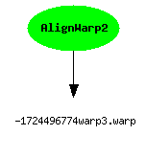

Figure xxx Query 8 results

9) A user has annotated some atlas graphics with key-value pair where the key is studyModality. Find all the graphical atlas sets that have metadata annotation studyModality with values speech, visual or audio, and return all other annotations to these files.

Discussion:
We used DavExplorer to annotate several atlas graphic files with metadata, because the SAM server supports arbitrary metadata there were no schema modifications required. Search criteria was used to return all properties on the processes containing the metadata ‘studyModality’ with the values ‘speech’, ‘audio’, or ‘visual’. The result format was set to GXL and converted to a gif image.

<d:searchrequest xmlns:d="DAV:">
<d:basicsearch>
<d:select>
<d:prop>
<d:allindexedprop/>
</d:prop>
<d:format d:include-links="false">gxl</d:format>
</d:select>
<d:from>
<d:scope>
<d:href>/sam/users/sdg/karen</d:href>
<d:depth>INFINITE</d:depth>
<d:min-depth>0</d:min-depth>
</d:scope>
</d:from>
<d:where>
<d:or>
<s:propcontains xmlns:s="http://jakarta.apache.org/slide/">
<d:prop>
<d:studyModality />
</d:prop>
<d:literal>audio</d:literal>
</s:propcontains>
<s:propcontains xmlns:s="http://jakarta.apache.org/slide/">
<d:prop>
<d:studyModality />
</d:prop>
<d:literal>visual</d:literal>
</s:propcontains>
<s:propcontains xmlns:s="http://jakarta.apache.org/slide/">
<d:prop>
<d:studyModality />
</d:prop>
<d:literal>speech</d:literal>
</s:propcontains>
</d:or>
</d:where>
</d:basicsearch>
</d:searchrequest>

Figure xxx SEDASL query for provenance query 9

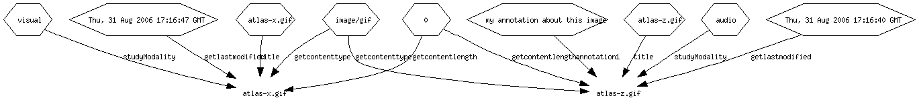
Figure xxx Query 9 raw results

Discussion

- Cool things about our implementation
  - Automatic type determination for content
  - Defuddle (DFDL) worked great for automated metadata extraction
  - Combining rdf assertions with content management is useful
  - Flexible event based model so as to minimize connections into workflow engine
  - Extended DASL through DASL extension mechanisms (ok so we cheated a little)
  - Indexing of content or metadata
  - Output can be returned in multiple formats
  - Query against content as well as metadata
  - Based on existing standards (http) – no special new protocol or infrastructure needed.
  - Everything is opensource
  - Content/prov store has pluggable authentication model base on JAAS
  - Extensible translation mechanism for captured file data. We can do things like display a table of warp parameter values (from binary .warp files)
  - Actors can contribute their own metadata easily through events
  - User control over which actors to capture provenance on
  - Capability to capture hashes instead of values
  - All relationships are reverse indexed automatically. You can search up or down and event mix directions on specific properties.
- Limitations
  - Prov capture is slow. We do one assertion at a time currently but they could all be packaged up into one request
  - RDF predicates can’t contain special characters but things like parameters often have these characters.
  - SAM can be made to work but current implementation based on WebDAV ties resources to metadata. We had to create dummy resources.
  - SAM not rdf based.
  - Big files (reference images) are duplicated as part of provenance tracking because they are data inputs to multiple actors.
- Kepler discussion points
  - Decided to stay with brute force model instead of loop based model. Loop based model would probably introduce controller actors that would obscure the provenance capture.
  - Issue of what to capture provenance on for more general workflows
  - Coding actors for each thing you want to do doesn’t scale and is a barrier to adoption by scientists.
  - Can’t control actor firing order which resulted in things like AlignWarp4 producing warp1.warp
  - We used string constant actors to supply input files but it makes more sense for Kepler to support the concept of a data source.
  - We could not tell if a port value was a file except by using File.exists()
  - Would like to see events be external for complete separation from workflow engine.
- Outside of Current Scope
  - Repeating workflows
  - Dynamically changing and continuing workflows (ie evolving workflows)
  - Pointing back to provenance on Actors. A real system would do this and the Actors themselves would have global ideas that could be referenced.
  - Capturing provenance on workflow descriptors and pointing back to them (same as above for actors)
  - Use of lsids – we have service running but never got to the point of inserting it. Instead we used a url name generation service.
  - Signing results

